-:PROPOSED METHEDOLOGY:-
Here we use 5 different model to predict the match result. On other way we can say that we compare between the models. By our data set we can predict the match result by two ways. One depends on the historical and another one depends on the on-going match result. So we part by part discuss the models and their working method briefly.
i) In case of NAIVE BAYES it simply use the Bayes' Theorem.In this case we can find the probability of event A when some other events like B,C,D is already happened.
P(A/B)=P(A).P(B/A)/P(B)
So here event A is our target column and others columns are the independent columns. Value of the probability of event B,C and D determines that what should be the value of the probability of the event A. It's a simple mathematics based methodology. So in scene of numeric methods the prediction is appropriate.
ii) Now the next model is KNN(K-Nearest Neighbors) model. It is a lazy learning process. Here the values of target columns are divided into their unique values. That means it divide them into classes. now it find the center for each class. Now at time of prediction it take k several point on the graph randomly and check at which class them fitted perfectly without changing their position.
DISTANCE FORMULA EUCLIDEAN
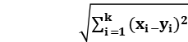
So for predicting the result of an individual it check the classes of those k points. Now there may be a tie. That's why to avoid the tie use always take k as odd. There is also two algorithm. One is uniform and another one is weighted. That means the vote of the closer point is more valuable than the vote of a fuhrer point.
iii) Next Logistic Regression, which actually comes from the word 'logit'. There is an function know as logit function or Sigmoid function for any value of X the value of F(X) or Y should be lies between 0 and 1.
A logistic function or logistic curve is a common "S" shape (sigmoid curve), with equation:
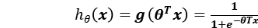
It is more appropriate at the time of binary prediction. where the prediction is in the form Yes/No. As in our work we get the same type of issue that's why logistic regression may be one of the best solution.
iv) Now Decision Trees are a type of Supervised Machine Learning (that is you explain what the input is and what the corresponding output is in the training data) where the data is continuously split according to a certain parameter. The tree can be explained by two entities, namely decision nodes and leaves. The leaves are the decisions or the final outcomes. And the decision nodes are where the data is split.

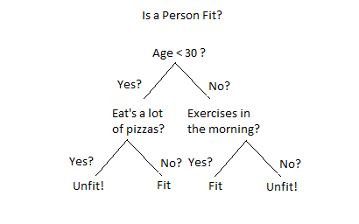
• Entropy
Entropy, also called as Shannon Entropy is
denoted by H(S) for a finite set S, is the measure of the amount of uncertainty or randomness in data.
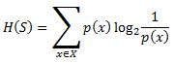
Intuitively, it tells us about the predictability of a certain event. Example, consider a coin toss whose probability of heads is 0.5 and probability of tails is 0.5. Here the entropy is the highest possible, since there’s no way of determining what the outcome might be.In other words, this event has no randomness, hence it’s entropy is zero.
• Information Gain
Information gain is also called as Callback-Libeler divergence denoted by IG(S,A) for a set S is the effective change in entropy after deciding on a particular attribute A. It measures the relative change in entropy with respect to the independent variables.
Alternatively,
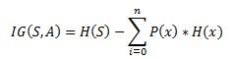
where IG(S, A) is the information gain by applying feature A. H(S) is the Entropy of the entire set, while the second term calculates the Entropy after applying the feature A, where P(x) is the probability of event x.
v) Last model is MLPClassifier of Neural Network. A Neural Network or NN has 3 layers .Input layer, hidden layer and output layer.
The performance of the NN highly depends on the initial weight vector that has been supplied to it at beginning of training phase. Generally, the weight vector is generated randomly keeping its component values within a given range.
Here the output values are only two types but they are randomly spread on the plane. That's why it is nearly impossible to separate these points using only one layer or surface. Here we need the concept of Multi-Layer-Perceptron or MLP. It is nothing but the feedforward artificial neural network. which learn using gradient descent technique. And this training method is known as backpropagation.
Based on the above mentioned algorithms we designed our models and found out the confusion matrix as well as we calculated the accuracy, precision, recall & f-measure scores.

